**Economic and Financial Analysis (EFA)**

**Accelerating the impact of CGIAR Climate Research for Africa project (AICCRA)**

**1. Introduction**

AICCRA is expected to generate several types of benefits:

(1) Primary benefits generated mainly during the Project life:

1. Strengthened human and institutional capacity to generate, assess, and make use of climate smart agriculture (CSA) technologies and climate information services (CIS) among CGIAR Centers, CCAFS partners, African regional organizations, national agriculture research and extension organizations (NAREs), civil society organizations, and private firms, among others.
2. Bridged gap between CGIAR-led science partnerships on the one hand and technology generation organizations and extension services on the other hand, resulting in faster and more extensive scaling-up of innovative technologies and improved availability of short-term and seasonal climate forecasts to service providers and to end users (e.g., farmers, livestock keepers, other food system actors, policy makers).
3. Enhanced regional integration of research for development activities, paving the way for more extensive dissemination of climate advisory services and more widespread scaling-up of innovative technologies through cross-border spillovers.

(2) Secondary benefits generated mainly after the Project has ended:

1. Increased productivity and enhanced climate resilience (reduced production variability) at farm-level, including positive outcomes for women.
2. More widespread adoption of CSA technologies due to regional spillovers.
3. Climate benefits in the form of reduced greenhouse gas (GHG) emissions.

Estimating the economic value of the benefits described under bullets 1, 2, and 3 would be difficult (costly, time consuming, and conceptually challenging), and it will not be attempted for purposes of the PAD. Nevertheless, the meta-analysis done by Pardey et al. (2016) provides compelling evidence that investments in food and agriculture research and development made in sub-Saharan Africa (SSA) over the last 40-50 years have generated attractive returns.

Since the benefits described under bullets 1, 2, and 3 are “enablers” of the benefits described under bullets 4, 5, and 6, the economic and financial analysis (EFA) focuses on the benefits described under the latter three. Caveat: the benefits described under bullets 4, 5, and 6 fall under the sphere of influence of the Project, but not under the sphere of control, because they depend in part on factors beyond the control of the Project (e.g., price incentives, availability of purchased inputs, weather conditions, etc.)

The EFA is carried out in four stages. In the first stage, the area that could potentially benefit from AICCRA is calculated (including both the target countries and the extrapolation domain). In the second stage, the value is calculated of the benefits that would result from a 1% increase in crop and livestock productivity over this entire area. In the third stage, the value of the benefits is adjusted in recognition of the fact that adoption will occur gradually over time and will not reach the entire area. In the fourth stage, measures of project worth are calculated recognizing that the investments to be made under AICCRA will make up only a very small share of investments to increase uptake of CSA technologies and use of CIS.

**2. Literature review: Benefits of CSA and CIS adoption**

Climate change poses a major threat in the areas being targeted by AICCRA. The Project will operate in several agro-ecological zones (AEZs), all of which are projected to experience significant temperature increases over the long term – up to 2.7 °C by the 2050s, if current greenhouse gas emission trajectories continue (Girvetz et al., 2019). In addition to rising average temperatures, a major source of uncertainty for the region’s farmers and pastoralists will be increased variability in rainfall, which will amplify risk throughout the growing season.

The following paragraphs provide evidence from the literature of the benefits of adoption of CSA technologies and the benefits of use of CIS.

**2.1. Benefits of adoption of CSA technologies**

A large and robust body of evidence shows that adoption of CSA technologies can be profitable and lead to desirable development outcomes. A recent systematic review of the scientific literature showed that at household level many CSA technologies can reduce production risks by up to 48% compared with business-as-usual approaches, as well as increasing the economic benefits to farmers by up to 40% (Nowak et al., 2019). The farm-level profitability of adopting CSA practices can vary, however, depending on local context and factors such as the distance to markets and local income inequalities. But a consistent finding is that few farm-level activities produce large benefits when practiced in isolation (Steward et al., 2019). There is extensive evidence that combinations of practices out-perform single practices across a variety of regions, agro-ecologies and socio-economic conditions (Khatri-Chhetri et al. 2016; Rigolot 2017; Henderson et al. 2018; Radeny et al. 2019). Nowak et al. (2020a) reviewed data from 27 peer-reviewed publications and calculated substantial economic benefits of CSA practices at the farm level, in terms of increases in gross margins per ha compared with conventional practices: 58%, 132%, 210% and 337% increases for agroforestry, soil management, crop management, and nutrient management practices, respectively. Most of these practices result in lower risks for farmers. Similar analysis for Malawi indicates gross margin changes of +47% and +61% for soil management and nutrient management practices, respectively, though a small decrease (-3%) for agroforestry practices (Nowak et al., 2020b). Adoption of drought tolerant maize varieties increased maize yields by 13% and reduced yield variance by 53% in Nigeria (Wossen et al., 2017), and increased yields by 150% in northern Ghana (Martey et al., 2020). The reasons for adoption and non-adoption of CSA practices at farm level are complex, and may relate to information availability, labour availability, credit availability for purchases of inputs (Ouédraogo et al., 2019; Diro et al., 2019), and other factors such as wealth indicators and tenure security (Arslan et al., 2020).

Beyond the large body of farm-level evidence, substantial benefits have been demonstrated at national level as well. Adopting CSA on 25% of the area planted to maize and wheat in Ethiopia would increase annual gross domestic product (GDP) by 0.18% (US$49.8 million) and reduce the national poverty rate by 0.15 percentage points. Moreover, CSA would be more effective than doubling fertilizer use on the same area (Komarek et al. 2019).

**2.2. Benefits of use of CIS**

Farmers who make use of CIS usually realize benefits, although the evidence is less conclusive (Vaughan et al., 2019). Evidence on the benefits of using CIS comes in the form of productivity or income benefits elicited through surveys or workshops, willingness to pay studies, field trials, and model-based decision analysis. One economy-wide equilibrium modeling study estimated the GDP gain from widespread adoption of seasonal forecasts across Kenya, Malawi, Mozambique, Tanzania, and Zambia would average $113 million per year, with a disproportionate share of the amount going to poorer households (Rodrigues et al. 2016). A more recent analysis estimated a 5% gain in GDP resulting from widespread adoption of weather and climate services in Ethiopia (Beyene et al. 2020). A CCAFS-led initiative in Rwanda has enabled more than 100,000 farmers to gain access to climate information services, through a combination of participatory processes (extension based, and radio listener programs). Relative to a control population, farmers that adopted climate services realized productivity gains of 24% or higher, and income gains of 30% or higher (Birachi et al. 2020). In Senegal, CCAFS has promoted uptake of CIS by providing advisory services supported by operational climate information, including seasonal forecasts. Relative to the control population, farmers making use of the climate advisory service have realized up to 20% gains in income, deriving from improvements in land preparation, crop choice, planting and harvesting dates, and conservation decisions (Chiputwa et al., 2020).

**3. Economic analysis**

**3.1. Methodology and data sources**

The increased productivity and enhanced climate resilience expected to result from AICCRA activities (i.e., resulting from greater use of CIS and more widespread adoption of CSA technologies) were estimated as follows.

The six target countries and the regions in which they are located were stratified based on AEZ and prevailing production system. The classification of Seré and Steinfeld was used (FAO, 1996), as described in Robinson et al. (2011).

Areas, human population numbers (from CIESIN, 2018), crop areas, production, yields and value of production (from HarvestChoice, 2017), and livestock numbers, production, and value of production (from Herrero et al., 2013) were calculated for all systems. For both crops and livestock products, the prices used in the HarvestChoice (2017) and the updated Herrero et al. (2013) data sets relate to 2005 international dollars. For crops, combined totals were calculated for all food crops, and separate totals were calculated for maize as a widely grown indicator crop. Maize was used as an indicator crop to provide indicative estimates of CSA benefits, rather than benefits from all food crops. Maize has several characteristics that make it a good indicator crop: it is sensitive to climate, and it is grown across a wide range of smallholder farm types. It is also important for food and nutrition security: in the six AICCRA anchor countries, maize supplies on average 20% of daily calorie requirements (in Zambia, 42%) (FAOSTAT, 2020). Maize was also used as the indicator crop to estimate the benefits of avoided yield losses because of reduced climate variability. Depending on the country, maize accounts for between 8 and 34% of the total food-crop value of production (VOP). For livestock, cattle were used as the indicator species, so productivity gains attributable to adoption of CSA technologies were based on productivity gains that have been observed in bovine meat and milk production. These data were all for 2005, nominally.

This information was generated for the six target countries and for 20 additional countries in the three regions, to make up the “extrapolation domain” including spillovers. For all three regions, the mixed crop-livestock production system was used for extrapolation. In the Seré and Steinfeld classification (FAO, 1996), the mixed crop-livestock systems are broken down into rainfed (MR) and irrigated (MI). The rainfed and irrigated categories are each further broken down into three AEZs: arid-semiarid, defined as a length of growing period (LGP) ≤180 days per year (MRA, MIA); humid-subhumid, with LGP >180 days per year (MRH, MIH); and tropical highland, defined as areas with a daily mean temperature during the growing period of 5-20 °C (MRT, MIT). In West Africa, most of CCAFS’s work with climate-smart villages (CSVs) has been carried out in the drier mixed rainfed systems (MRA), and so for estimating regional spillovers in West Africa, the MRA system (and the small amounts of MIA system) was used as the extrapolation domain. For Zambia, much of the cropland is located in the MRA and MIA (to a much lesser extent) systems, and so these systems were used for extrapolation purposes in the southern Africa region too. In most countries of both West and southern Africa, there are only small amounts of the MRT system. For East Africa, CCAFS has been active across all mixed system types, so for the extrapolation domain for East Africa, the MRA, MRH and MRT systems were used (along with much smaller areas of MIA, MIH and MIT systems). All spatial variables were standardized to grids of 5 arcminute resolution. The extrapolation domains for each region are mapped in Figures 1, 2 and 3. These domains include the countries with significant areas of the mixed crop-livestock systems in the appropriate AEZs, on the basis that CSA and CIS technologies that have been validated in particular AEZs in the target countries in each region may also have potential for being adopted in similar AEZs in other countries in the same region.

**3.1. Direct benefits of CSA practices via increased yields**

Table 1 shows the estimated direct benefits of adoption of CSA practices in the six target countries, expressed as the increase in value of production per year per percentage point increase in crop, meat and milk yield – that is, assuming adoption over all the maize area and all cattle in the target systems of a technology that increased production per ha or per animal by 1%.

**Table 1.** Increases in value of production (2005 USD x 1000) in food crops, maize, bovine meat and bovine milk for a 1% increase in yield throughout the mixed crop-livestock systems in AICCRA target countries

|  |  |  |  |  |  |  |  |
| --- | --- | --- | --- | --- | --- | --- | --- |
|  | **Country and systems included** | | | | | | **Total** |
|  | **Ethiopia** | **Ghana** | **Kenya** | **Mali** | **Senegal** | **Zambia** |  |
|  | **MRA, MRH, MRT, MIA, MIH, MIT** | **MRA, MIA** | **MRA, MRH, MRT, MIA, MIH, MIT** | **MRA, MIA** | **MRA, MIA** | **MRA, MIA** |  |
| **Maize** | 4,834 | 98 | 3,521 | 758 | 404 | 691 | 10,405 |
| **Other food crops** | 32,550 | 4,638 | 13,439 | 7,990 | 5,474 | 1,092 | 65,181 |
| **Bovine meat** | 9,594 | 119 | 2,200 | 792 | 546 | 44 | 13,294 |
| **Bovine milk** | 8,834 | 32 | 2,117 | 194 | 134 | 65 | 11,377 |
| **Total** | 55,813 | 4,986 | 21,276 | 9,734 | 6,557 | 1,891 | 100,258 |

Systems based on Robinson et al. (2011): MR = mixed rainfed; MI = mixed irrigated; A = arid-semiarid; H = humid-subhumid; T = tropical highland.

Table 2 converts the benefits in Table 1 to a range of plausible adoption rates and productivity increments at scale. Calculations are shown in the annex. The productivity increments in Table 2 are well within what has been observed in many situations for a range of single CSA practices as well as combinations (see text above). Regarding adoption rates, there are not many examples of agricultural technology adoption rates at scale in excess of 2% per year (see Thornton and Herrero, 2010, for example). The annual adoption rates used in Table 2 refer to the total area of crop and number of cattle that have not yet adopted over a ten-year period, so 2% adoption in year 8 is not the same number as 2% adoption in year 2, for example. For this reason, the estimates of VOP addition are not simple linear multiples of the adoption rate per year shown.

**Table 2.** Marginal increases in value of production per year at year 10 (2005 USD, millions) of maize, bovine meat and bovine milk for different plausible yield benefits and annual adoption rates in the mixed crop-livestock systems in AICCRA target countries (Ethiopia, Ghana, Kenya, Mali, Senegal, Zambia)

|  |  |  |  |  |  |  |
| --- | --- | --- | --- | --- | --- | --- |
|  | **5% Productivity increment** | | | **10% Productivity increment** | | |
| **Annual adoption rate** | **1%** | **2%** | **3%** | **1%** | **2%** | **3%** |
| **Maize** | $5.44 | $ 11.39 | $17.89 | $10.89 | $22.79 | $35.79 |
| **Bovine meat** | $6.95 | $14.56 | $22.86 | $13.91 | $29.11 | $45.72 |
| **Bovine milk** | $5.95 | $12.46 | $19.56 | $11.90 | $24.91 | $39.13 |
| **Total** | $18.34 | $38.41 | $60.31 | $36.70 | $76.81 | $120.64 |

**3.2. CSA adoption: Spillover benefits**

Table 3 shows the estimated spillover benefits of adoption of CSA practices in the 20 “extrapolation domain” countries, expressed as in Table 1 in terms of the increase in value of production per year per percentage point increase in crop, meat and milk yield (i.e., assuming adoption over all the cropping areas and all cattle in the target systems). Table 4 shows the marginal benefits in value of production for plausible (but much lower, given that these are spillover impacts) adoption rates and the same productivity increments as in Table 2.

**Table 3.** Increases in value of production (2005 USD x 1000) of maize, other food crops, bovine meat and bovine milk for a 1% increase in yield throughout the mixed crop-livestock systems in the 20 AICCRA “spillover” countries.

|  |  |  |  |  |
| --- | --- | --- | --- | --- |
|  | **Region, Countries, Systems** | | |  |
|  | **East Africa:**  **Burundi, Rwanda, Tanzania, Uganda** | **West Africa:**  **Benin, Burkina Faso, Chad, Cote d’Ivoire, Cameroon, Guinea, Gambia, Guinea-Bissau, Mauritania, Niger, Nigeria, Togo** | **Southern Africa: Botswana, Malawi, Mozambique, Zimbabwe** | **Total** |
|  | **MRA, MRH, MRT, MIA, MIH, MIT** | **MRA, MIA** | **MRA, MIA** |  |
| **Maize** | 12,760 | 15,082 | 6,087 | 33,929 |
| **Other food crops** | 180,824 | 403,858 | 32,566 | 617,248 |
| **Bovine meat** | 8,477 | 13,184 | 1,802 | 23,463 |
| **Bovine milk** | 9,943 | 4,142 | 1,574 | 15,659 |
| **Total** | 212,004 | 436,266 | 42,029 | 690,299 |

Systems based on Robinson et al. (2011): MR = mixed rainfed; MI = mixed irrigated; A = arid-semiarid; H = humid-subhumid; T = tropical highland.

**Table 4.** Marginal increases in value of production per year at year 10 (2005 USD, millions) of maize, bovine meat and bovine milk for a range of plausible productivity benefits and adoption rates per year in the mixed crop-livestock systems in the 20 AICCRA “spillover” countries.

|  |  |  |  |  |  |  |
| --- | --- | --- | --- | --- | --- | --- |
|  | **5 % Productivity increment** | | | **10% Productivity increment** | | |
| **Annual adoption rate** | **0.1 %** | **0.2%** | **0.3%** | **0.1%** | **0.2%** | **0.3%** |
| **Maize** | $7.77 | $15.49 | $23.17 | $15.53 | $30.98 | $46.35 |
| **Bovine meat** | $61.47 | $123.50 | $186.09 | $122.95 | $247.00 | $372.18 |
| **Bovine milk** | $0.79 | $1.58 | $2.38 | $1.57 | $3.16 | $4.76 |
| **Total** | $70.03 | $140.57 | $211.64 | $295.48 | $281.14 | $423.29 |

**3.3. Benefits of yield losses avoided through use of CIS**

The benefits for farmers who use climate information services arise from their being able to adjust their management practices to likely imminent or future weather patterns. If the growing season is likely to be wetter than average, then it may be appropriate to increase the use of purchased inputs to increase production and net revenues, for example. For drier conditions, CIS can help farmers and herders reduce production losses via a range of management decisions (such as sale of animals or reducing cropping inputs). The long-term implications of a drought on vulnerable households may be profound, because such a “system shock” can push farmers and their families into poverty from which it can be difficult to escape (Barrett et al., 2016).

The use of CIS will not only reduce production variability, it should also increase average yields. This latter effect is not included in the CIS analysis done here as it would double-count the benefits already estimated from CSA technology adoption. An assumption in the EFA is that CSA adoption leads to production benefits (increases in distribution means) and that CSI leads to reductions in yield losses in poorer seasons (reductions in production standard deviations). Thus the target populations for CSA and CIS are essentially the same, which is judged to be appropriate in the AICCRA context in view of the fact that weather-related production variability in the arid-semiarid mixed systems of SSA can be considerable.

Annual national yield variability was calculated from FAOSTAT for each of the six target countries for the last 30 years available (1989-2018). Maize yield CVs for the target and extrapolation countries are about 75% for southern Africa, 37% for East Africa, and 34% for West Africa.

Because CIS are still relatively new in SSA, information on the potential for the use of CIS to reduce yield variability is still scarce. To the extent that use of CIS prompts changes in technology choice, the impacts can be significant; as noted above, Wossen et al. (2017) reported that yield variance in farmers’ fields can be halved via the use of drought-tolerant maize.

One way to translate reduced yield variability into production benefits is to calculate the economic losses avoided (in terms of value of production) for a percentage reduction in yield CV, measured with respect to the left-hand tail of the production distribution. A very approximate estimate is to assume that maize yields in farmers’ fields are distributed normally and calculate the difference in the probability densities of two normal yield density curves, one with the observed mean and yield CV and another with the same mean but a reduced yield CV. For maize grown in the MRA systems in the target countries, average yield is 1.24 t/ha, and the yield CV is about 35%. This indicates a yield standard deviation of 0.43 t/ha. For example, if the CV is reduced to 30% with the same mean, the new standard deviation is 0.37 t/ha. The area between the PDFs of these two normal distributions in the left-hand tails (i.e., the total of the yield loss foregone because of the reduction in CV from 35% to 30%), amounts to 3.3% of total production. Values of the loss avoided are shown in Table 5 for the same adoption rates used in Tables 2 and 4. In practice, mean yields will increase through the use of CIS, but as explained above the focus here is on the avoided losses, which may be extremely important for household food security.

**Table 5.** Value of production losses avoided per year at year 10 (2005 USD, millions) via a reduction in the CV of annual maize production from 25% to 20% (e.g. through the use of CIS) in the MRA mixed crop-livestock systems.

|  |  |  |  |  |  |  |
| --- | --- | --- | --- | --- | --- | --- |
|  | **3.3% maize productivity increment (loss avoided)** | | | | | |
| **Annual adoption rate** | **0.1 %** | **0.2%** | **0.3%** | **1%** | **2%** | **3%** |
| **AICCRA target countries** |  |  |  | $16.49 | $32.08 | $46.8 |
| **Spillover countries** | $5.1 | $10.2 | $15.3 |  |  |  |

**4. Indicative AICCRA returns on investment**

The information presented in the tables above illustrates estimated changes in the value of production of different commodities for different production increments and adoption rates. To estimate returns on investment (though without estimating the costs of the “enablers” – see paragraph above on the primary benefits), some estimate is needed of the direct costs of implementing CSA and CIS technologies at the farm lavel, so that cash flows can be calculated on changes in net profits or grow margins per ha or per animal.

Harris and Orr (2013) provide benefit-cost ratios for a wide range of smallholder agricultural production technologies using many household-level datasets in countries throughout SSA (and India). Many of these technologies for different crops can be classed as CSA (e.g., conservation tillage, crop rotations and crop mixtures, fertilizer micro-dosing, and many others). Median net returns increased from $186 per ha (in 2005 $) for “baseline technologies” to $558 per ha for the 64 technologies considered, and the median Benefit-Cost Ratio (BCR) from 1.62 to 2.24 for the 49 technologies for which this was reported (Harris and Orr, 2013). This combination of increases in net returns and BCR implies an increase in costs per ha of implementing the CSA technologies at the farm level, compared with the baselines, by a factor of about 2.2.

Table 6 shows the Net Present Value (NPV), Internal Rate of Return (IRR) and BCR for the AICCRA project for a range of conservative adoption rates and yield increments, with the assumptions that the investment is allocated to the indicator crop (maize), and that the marginal VOP additions each year from CSA and CIS adoption are adjusted by a factor of 2.5 to account for the increased costs of implementation at the farm level (as above) plus the essentially unknown off-farm costs (increased market access, improved seed production, etc).

Table 7 shows the NPV, IRR and BCR for the AICCRA spillover countries for a range of conservative adoption rates and yield increments, with the same assumptions as in Table 6, though here just for CSA technology adoption.

**Table 6.** Investment criteria to 2030 using a discount rate of 5% for maize CSA and CIS adoption for different plausible yield benefits and adoption rates per year in the mixed crop-livestock systems of the AICCRA anchor countries (Ethiopia, Ghana, Kenya, Mali, Senegal, Zambia).

|  |  |  |  |  |  |  |
| --- | --- | --- | --- | --- | --- | --- |
|  | **Benefits of CSA and CIS adoption** | | | | | |
|  | **15% yield benefit + 3.3% avoided loss** | | | **30% yield benefit + 3.3% avoided loss** | | |
| **Annual adoption rate** | **1 %** | **2%** | **3%** | **1%** | **2%** | **3%** |
| **(implied adoption % by 2030)** | **9.1%** | **17.4%** | **25.0%** | **9.1%** | **17.4%** | **25.0%** |
| **NPV (2005 $ million)** | -$2.66 | $48.9 | $97.9 | $54.7 | $160.7 | $261.1 |
| **IRR (%)** | 4.3% | 15% | 23% | 16% | 30% | 41% |
| **B/C ratio** | 0.95 | 1.86 | 2.71 | 2.75 | 3.81 | 5.57 |

**Table 7.** Investment criteria to 2030 using a discount rate of 5% for maize CSA adoption for different plausible yield benefits and adoption rates per year in the mixed crop-livestock systems of the AICCRA spillover countries.

|  |  |  |  |  |  |  |
| --- | --- | --- | --- | --- | --- | --- |
|  | **Benefits of CSA adoption** | | | | | |
|  | **15% yield benefit** | | | **30% yield benefit** | | |
| **Annual adoption rate** | **1 %** | **2%** | **3%** | **1%** | **2%** | **3%** |
| **(implied adoption % by 2030)** | **9.1%** | **17.4%** | **25.0%** | **9.1%** | **17.4%** | **25.0%** |
| **NPV (2005 $ million)** | $34.5 | $121.6 | $204.3 | $150.2 | $347.0 | $534.1 |
| **IRR (%)** | 12% | 25% | 34% | 28% | 45% | 57% |
| **B/C ratio** | 1.60 | 3.13 | 4.58 | 3.63 | 7.07 | 10.35 |

**5. Sensitivity analysis**

The robustness of some key assumptions of the EFA was tested for one of the scenarios shown in Table 6: a 2% adoption rate of both CSA technologies and CIS, and a 15% yield benefit resulting from the adoption of CSA. Results are shown in Table 8, with respect to (1) increases in the discount rate used, (2) less conservative estimates of yield losses avoided through the use of CIS, and (3) changes in the total costs of implementation of both CSA and CIS. The results of the investment analysis using less conservative estimates of the benefits of avoided production losses are particularly noteworthy.

It is recognized that realizing the benefits evaluated will depend on many factors in addition to AICCRA investments. Given the challenge of attributing benefits to the AICCRA investment directly, compared with attributing benefits to other activities and investments made in the anchor countries and across the regions more generally, the returns to the AICCRA investment in this EFA have been estimated using extremely conservative assumptions. These include conservative estimates of CSA technology and CIS adoption rates, as well as conservative estimates of CSA production benefits and CIS-informed production losses avoided. Furthermore, the analysis was built around just one (albeit important) indicator crop to represent the complexity and variation in the mixed crop-livestock farming systems in the different regions of SSA. Even with such conservative assumptions, AICCRA investments are expected to generate attractive returns. It may reasonably be expected that AICCRA would generate even more attractive returns that indicated in Tables 6 and 7, if the VOP benefits of production increases and avoided losses for beef, milk and other key food crops were to be taken into account. In light of the evidence in Steward et al. (2019), bundled packages of CIS and CSA options, including livestock production-enhancing technologies, would likely increase these investment returns even further.

**Table 8.** Sensitivity analysis for AICCRA investment criteria to 2030 for different discount rates, CIS benefits, and implementation costs in the mixed crop-livestock systems of the AICCRA anchor countries.

|  |  |  |  |  |
| --- | --- | --- | --- | --- |
|  | **Scenario** | **NPV (2005 $ million)** | **IRR (%)** | **B/C ratio** |
| 1 | Baseline:   * 2% adoption per year * 15% CSA yield benefit * CIS avoided loss benefit 3.3% (CV of annual yield reduced from 35% to 30%) * implementation cost factor 2.5 * 5% discount rate | $48.9 | 15% | 1.86 |
|  | ***CIS effectiveness*** |  |  |  |
| 2 | CV of annual yield reduced from 35% to 25% (CIS avoided loss benefit 6.4%) | $66.4 | 18% | 2.16 |
| 3 | CV of annual yield reduced from 35% to 20% (CIS avoided loss benefit 12.2%) | $101.8 | 23% | 2.78 |
|  | ***Implementation cost changes*** |  |  |  |
| 4 | Implementation cost factor changed from 2.5 to 2.0 | $75.5 | 20% | 2.32 |
| 5 | Implementation cost factor changed from 2.5 to 3.0 | $31.3 | 12% | 1.55 |
|  | ***Discount rate changes*** |  |  |  |
| 6 | Discount rate changed from 5% to 6% | $41.9 | 15% | 1.74 |
| 7 | Discount rate changed from 5% to 7% | $35.5 | 15% | 1.63 |

**Figure 1.** West Africa domain for AICCRA extrapolation: shaded areas show the mixed rainfed crop-livestock systems, arid-semi-arid (LGP≤180 days per year) (MRA). System classification from Sere and Steinfeld (1996), mapped in Robinson et al. (2011). Anchor countries in bold italic, other named countries are included in the extrapolation domain.

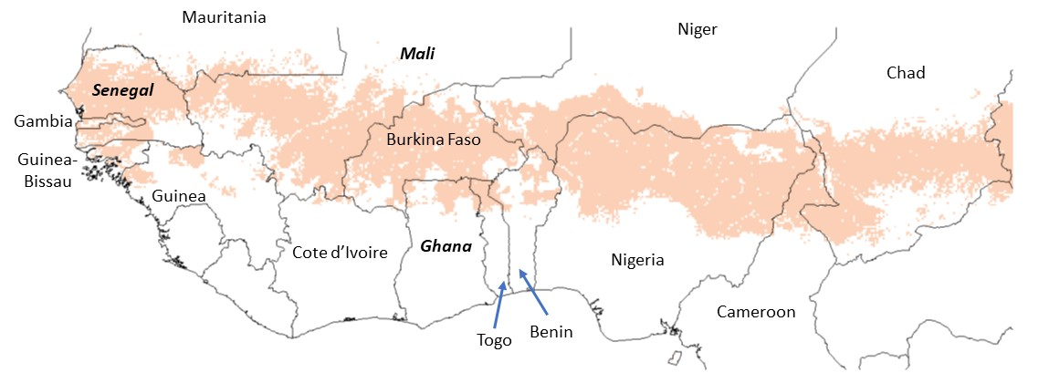

**Figure 2**. Southern Africa domain for AICCRA extrapolation: shaded areas show the mixed crop-livestock systems, arid-semi-arid (LGP<180 days per year) (MRA). System classification from Sere and Steinfeld (1996), mapped in Robinson et al. (2011). Anchor countries in bold italic, other named countries are included in the extrapolation domain.

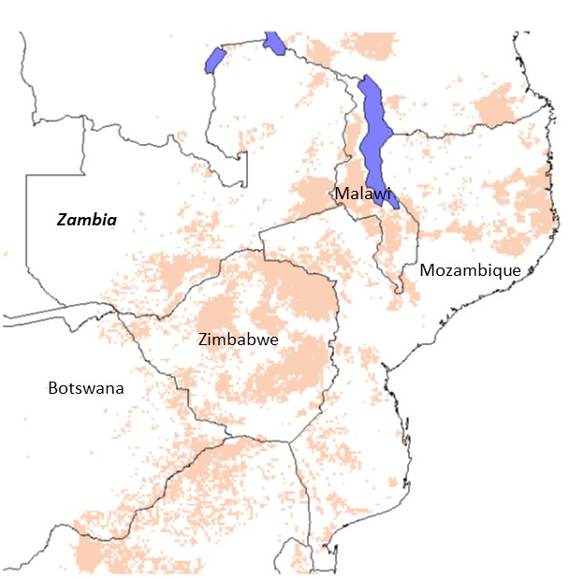

**Figure 3**. East Africa domain for AICCRA extrapolation. System classification from Sere and Steinfeld (1996), mapped in Robinson et al. (2011). Anchor countries in bold italic, other named countries are included in the extrapolation domain.

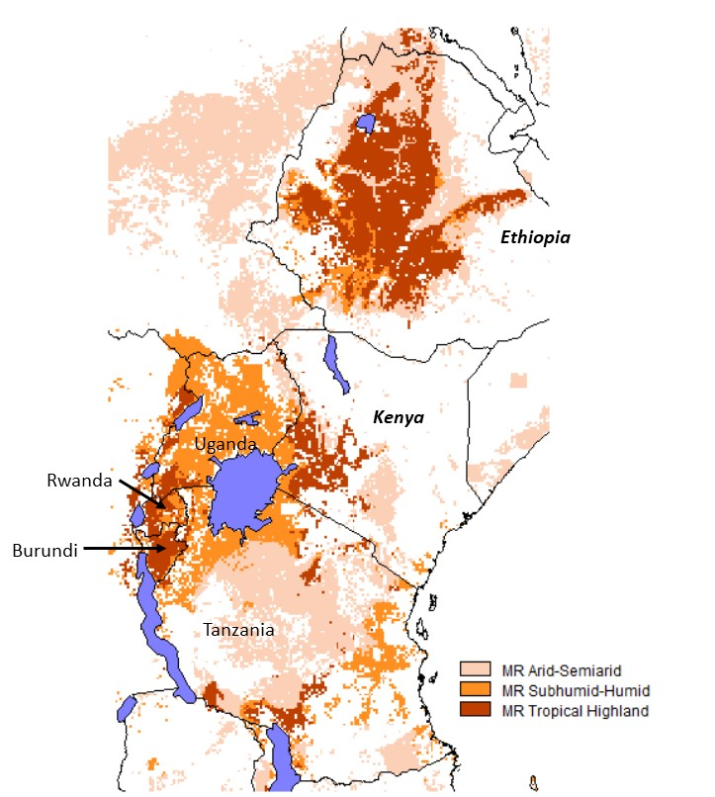

**References**

Arslan A, Floress K, Lamanna C, Lipper L, Asfaw S, Rosenstock T, 2020. The adoption of improved agricultural technologies: A meta-analysis for Africa. IFAD (in press).

Barrett, C.B., Garg, T. and McBride, L., 2016. Well-being dynamics and poverty traps. Annual Review of Resource Economics, 8, pp.303-327.

Birachi E, Hansen J, Radeny M, Mutua M, Mbugua MW, Munyangeri Y, Rose A, Chiputwa B, Solomon D, Zebiak SE, Kagabo DM. 2020. Rwanda Climate Services for Agriculture: Evaluation of farmers’ awareness, use and impacts. CCAFS Working Paper no. 304. Wageningen, the Netherlands: CGIAR Research Program on Climate Change, Agriculture and Food Security (CCAFS).

Cacho, O., Paolantonio, A., Branca, G., Cavatassi, R., Arslan, A. and Lipper, L., 2018. Identifying strategies to enhance the resilience of smallholder farming systems: evidence from Zambia. In Climate Smart Agriculture (pp. 425-441). Springer, Cham.

Center for International Earth Science Information Network - CIESIN - Columbia University. 2018. Gridded Population of the World, Version 4 (GPWv4): Population Count Adjusted to Match 2015 Revision of UN WPP Country Totals, Revision 11. Palisades, NY: NASA Socioeconomic Data and Applications Center (SEDAC). https://doi.org/10.7927/H4PN93PB.

Chiputwa, B.; Wainaina, P.; Makui, P.; Nakelse, T., Zougmoré, R.; Ndiaye, O, 2019. Evaluating the impact of the multidisciplinary working group model on farmers’ use of climate information services in Senegal. Report to USAID, 2019.

Chiputwa B, Blundo-Canto G, Andrieu N, Ndiaye O, 2020. Dynamic uptake of CIS use and impacts

on agricultural productivity and incomes: does co-production make a difference? CCAFS draft paper.

Clarke, D.J. and Hill, R.V., 2013. Cost-benefit analysis of the African risk capacity facility, IFRPI Discussion Paper 1292). Intl Food Policy Res Inst.

Diro, S., Getahun, W., Alemu, A., Yami, M., Mamo, T. and Mebratu, T., 2019. Cost and Benefit Analysis of Dairy Farms in the Central Highlands of Ethiopia. Ethiopian Journal of Agricultural Sciences, 29(3), pp.29-47.

FAO, 1996. World livestock production systems: current status, issues and trends, by Seré, C. & Steinfeld, H. FAO Animal Production and Health Paper 127. Rome, Food and Agriculture Organization of the United Nations (FAO), Animal Production and Health Division.

FAOSTAT, 2020. Country food balances for 2017. http://www.fao.org/faostat/en/#data/FBS

Girvetz, E., Ramirez-Villegas, J., Claessens, L., Lamanna, C., Navarro-Racines, C., Nowak, A., Thornton, P. and Rosenstock, T.S., 2019. Future Climate Projections in Africa: Where Are We Headed? In: The Climate-Smart Agriculture Papers (pp. 15-27). Springer, Cham.

Harris, D. and Orr, A., 2014. Is rainfed agriculture really a pathway from poverty? Agricultural Systems 123, 84-96.

HarvestChoice, International Food Policy Research Institute (IFPRI); University of Minnesota, 2017, "CELL5M: A Multidisciplinary Geospatial Database for Africa South of the Sahara", https://doi.org/10.7910/DVN/G4TBLF, Harvard Dataverse, V5

Henderson, B., Cacho, O., Thornton, P., van Wijk, M. and Herrero, M., 2018. The economic potential of residue management and fertilizer use to address climate change impacts on mixed smallholder farmers in Burkina Faso. Agricultural Systems, 167, pp.195-205.

Herrero M, Havlík P, Valin H, Notenbaert AM, Rufino M, Thornton P K, Blummel M, Weiss F, Obersteiner M (2013). Global livestock systems: biomass use, production, feed efficiencies and greenhouse gas emissions. PNAS 110 (52), 20888-20893.

Khatri-Chhetri, A., Aryal, J.P., Sapkota, T.B. and Khurana, R., 2016. Economic benefits of climate-smart agricultural practices to smallholder farmers in the Indo-Gangetic Plains of India. Current Science, pp.1251-1256.

Komarek, A.M., Thurlow, J., Koo, J. and De Pinto, A., 2019. Economywide effects of climate‐smart agriculture in Ethiopia. Agricultural Economics, 50(6), pp.765-778.

Martey, E., Etwire, P.M. and Kuwornu, J.K., 2020. Economic impacts of smallholder farmers’ adoption of drought-tolerant maize varieties. Land Use Policy, 94, p.104524.

Ng’ang’a, Stanley Karanja; Miller, Vail; Essegbey, George; Karbo, Naaminong; Ansah, V.; Nautsukpo, Delali; Kingsley, Sam; Girvetz, Evan. 2017. Cost and benefit analysis for climate-smart agricultural (csa) practices in the coastal savannah agro-ecological zone (aez) of Ghana. International Center for Tropical Agriculture CIAT, USAID. Cali.CO. 50 p.

Nowak AC, Wilkes A, Rosenstock TS. 2019. Measurement and reporting of climate-smart agriculture: technical guidance for a country-centric process. CCAFS Working Paper No. 274. Wageningen, the Netherlands: CGIAR Research Program on Climate Change, Agriculture and Food Security (CCAFS).

Nowak A, Steward P, Rosenstock T, 2020a. The business case for resilient agriculture: a financial and risk analysis of maize farming technologies in Kenya. ICRAF, Nairobi.

Nowak A, Steward P, Rosenstock T, 2020b. The business case for resilient agriculture: a financial and risk analysis of maize farming technologies in Malawi. ICRAF, Nairobi.

Ogada, M.J., Rao, E.J.O., Radeny, M., Recha, J.W. and Solomon, D. 2020. Climate-smart agriculture, household income and asset accumulation among smallholder farmers in the Nyando basin of Kenya. World Development Perspectives 18:100203

Ouédraogo M, Barry S, Zougmoré RB, Partey ST, Somé L, Baki G. 2018. Farmers’ Willingness to Pay for Climate Information Services: Evidence from Cowpea and Sesame Producers in Northern Burkina Faso. Sustainability 10(3):611

Ouédraogo M, Houessionon P, Zougmoré RB, Partey ST. 2019. Uptake of Climate-Smart Agricultural Technologies and Practices: Actual and Potential Adoption Rates in the Climate-Smart Village Site of Mali. Sustainability 11(17):4710.

Pardey, P.G., Andrade, R.S., Hurley, T.M., Rao, X. and Liebenberg, F.G., 2016. Returns to food and agricultural R&D investments in Sub-Saharan Africa, 1975–2014. Food Policy 65, 1-8.

Radeny M, Ogada MJ, Recha J, Kimeli P, Rao EJO, Solomon D. 2018. Uptake and Impact of Climate-Smart Agriculture Technologies and Innovations in East Africa. CCAFS Working Paper no. 251. Wageningen, Netherlands: CGIAR Research Program on Climate Change, Agriculture and Food Security (CCAFS).

Rigolot, C., De Voil, P., Douxchamps, S., Prestwidge, D., Van Wijk, M., Thornton, P.K., Rodriguez, D., Henderson, B., Medina, D. and Herrero, M., 2017. Interactions between intervention packages, climatic risk, climate change and food security in mixed crop–livestock systems in Burkina Faso. Agricultural Systems, 151, pp.217-224.

Robinson, T.P., Thornton P.K., Franceschini, G., Kruska, R.L., Chiozza, F., Notenbaert, A., Cecchi, G., Herrero, M., Epprecht, M., Fritz, S., You, L., Conchedda, G. & See, L. 2011. Global livestock production systems. Rome, Food and Agriculture Organization of the United Nations (FAO) and International Livestock Research Institute (ILRI), 152 pp

Rodrigues, J., Thurlow, J., Landman, W., Ringler, C., Robertson, R.D. and Zhu, T., 2016. The economic value of seasonal forecasts stochastic economywide analysis for East Africa (Vol. 1546). Intl Food Policy Res Inst.

Rollins KS, Shaykewich J, 2006. Using willingness‐to‐pay to assess the economic value of weather forecasts for multiple commercial sectors. Meteorological Applications 10, 31-38. https://doi.org/10.1017/S1350482703005048

Steward P, Lamanna C, Rosenstock T, 2019. Bundles of Joy? Using the ERA database to explore the outcomes of CSA practice interactions. Presentation at the Global Science Conference for Climate-Smart Agriculture 8-11 October 2019. Bali, Indonesia. https://hdl.handle.net/10568/106210

Tesfaye, A., Hansen, J., Kassie, G.T., Radeny, M. and Solomon, D., 2019. Estimating the economic value of climate services for strengthening resilience of smallholder farmers to climate risks in Ethiopia: A choice experiment approach. Ecological Economics, 162, pp.157-168.

Thornton P K and Herrero M, 2010. The potential for reduced methane and carbon dioxide emissions from livestock and pasture management in the tropics. PNAS 107 (46), 19667–19672. doi/10.1073/pnas.0912890107

Vaughan, C., Hansen, J., Roudier, P., Watkiss, P. and Carr, E., 2019. Evaluating agricultural weather and climate services in Africa: Evidence, methods, and a learning agenda. Wiley Interdisciplinary Reviews: Climate Change, 10(4), p.e586.

Wossen, T., Abdoulaye, T., Alene, A., Feleke, S., Menkir, A. and Manyong, V., 2017. Measuring the impacts of adaptation strategies to drought stress: the case of drought tolerant maize varieties. Journal of Environmental Management, 203, pp.106-113.

**Annex: Calculations**

From the gridded data, we have:

* VOP, value of production ($ per year)
* A, area planted, or numbers of cattle (ha or head)
* P, production (t)
* R, price ($/t), given by VOP / P

Assume adoption rate ***a*** (% per year)

Assume a productivity increment ***y*** (%, flat rate one-off)

Y = P/A in t/ha or kg/head

NB we used derived yields rather than spatial values because of spatial data alignment issues.

***For adopters over 10 years,***

Y’ = Y * (1+y/100) increased yield

A’ = A * (1 + a/100)^10 – A increasing area under adoption, a% per year

VOP’ = Y’ * A’ * R VOP from adopters

***For non-adopters,***

Y’’ = Y same yield

A’’ = A – A’ decreasing share of the area as adoption increases through time

VOP’’ = Y * A’’ * R VOP from non-adopters

VOP tot = VOP’ + VOP’’ At year 10, total VOP from adopters and non-adopters

Thus the marginal benefits of adoption per year at year 10 is:

VOP delta = VOP tot – VOP

After some algebra,

VOP delta = VOP * (1 - (((1+a/100)^10 ) - 1)) + VOP * (1+y/100) * (((1+a0/100)^10) - 1) – VOP